1. **Downloaded git bash :   
     
   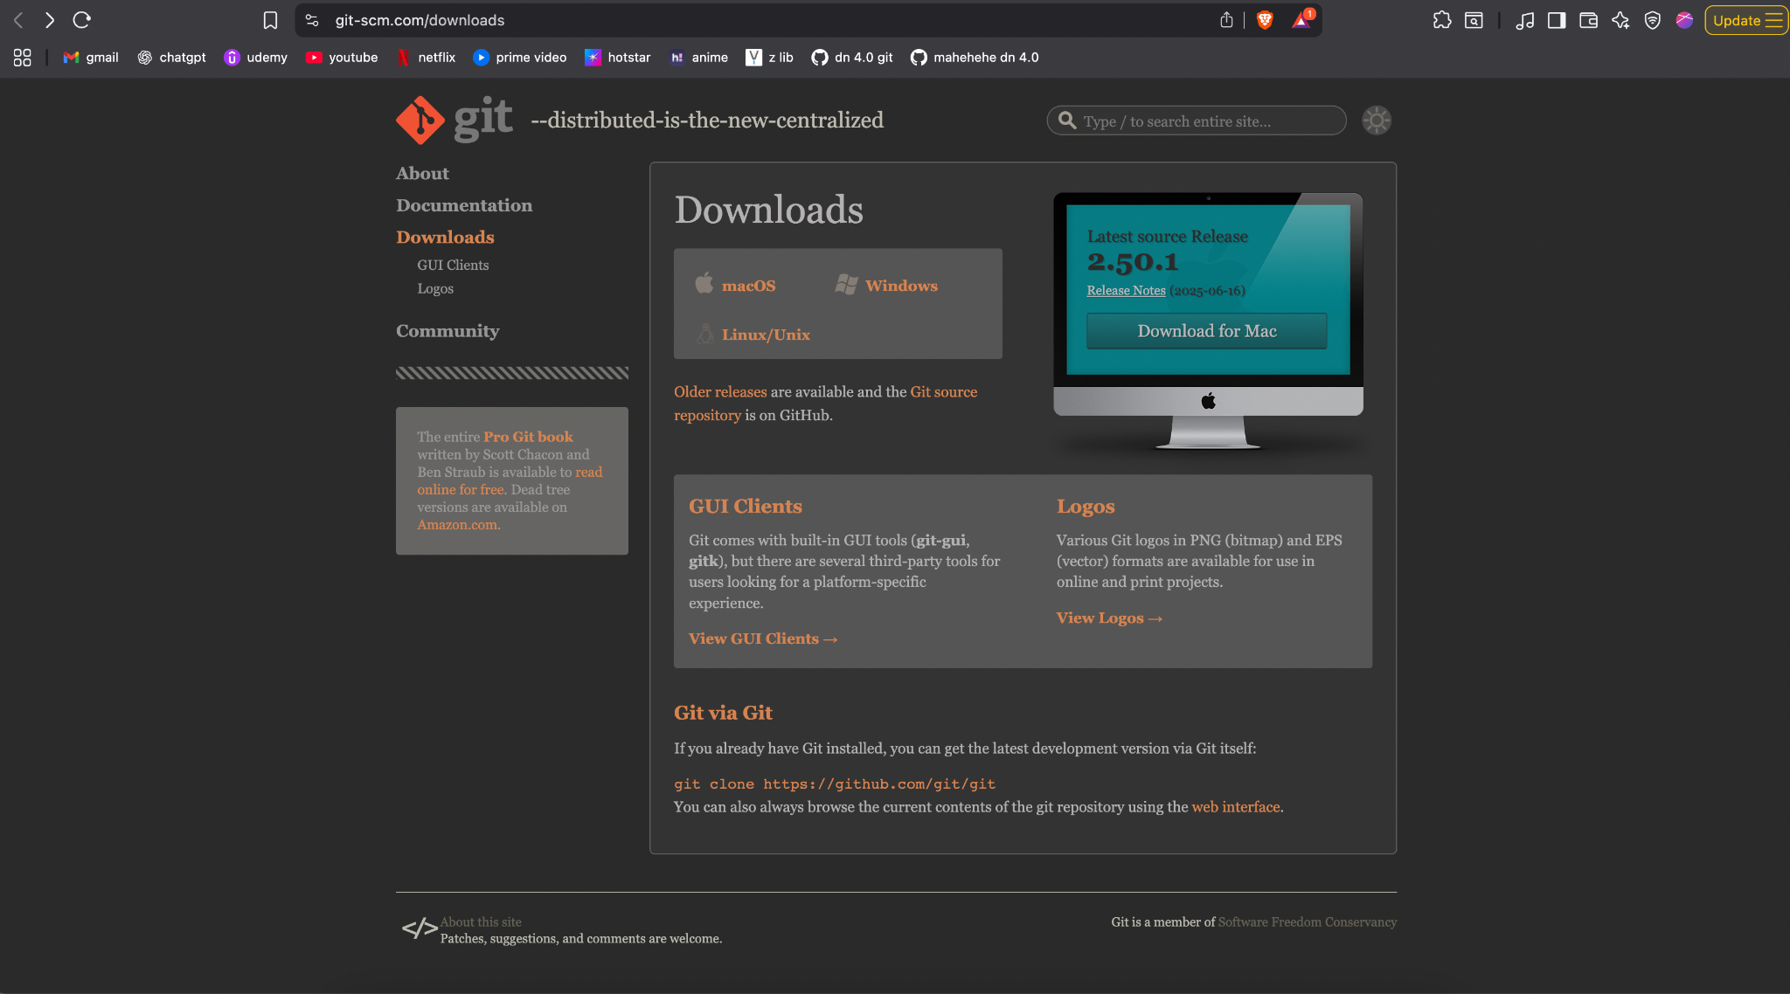**

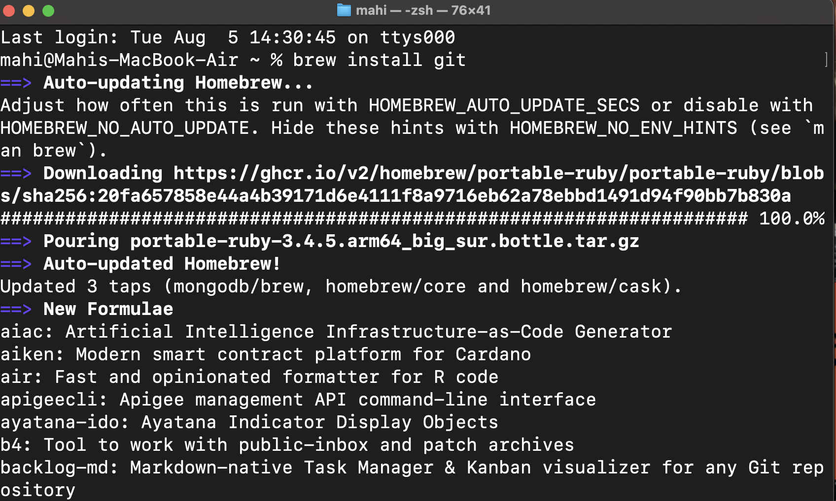

1. **Verified installation and configured GitLabs mail and username :**



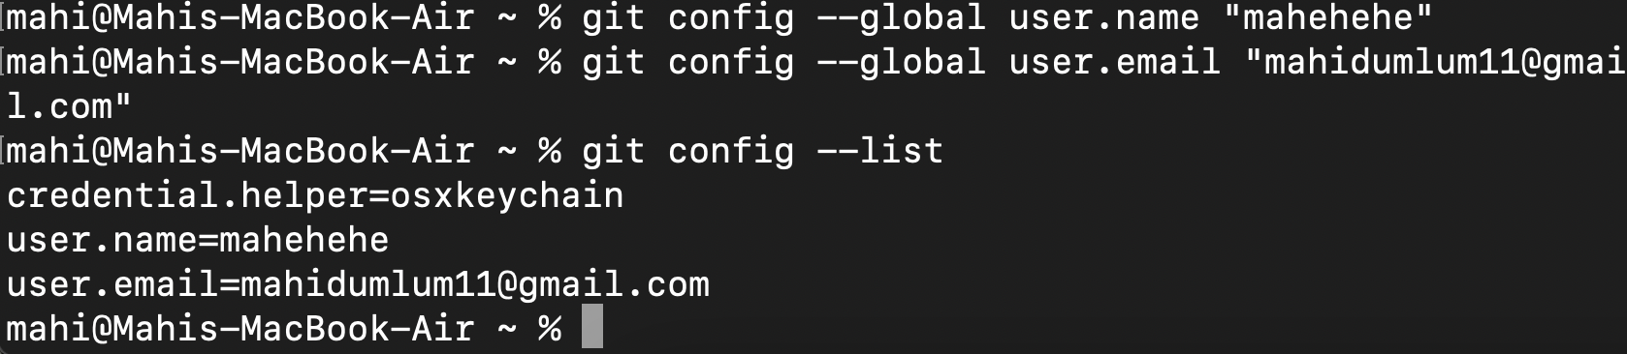

1. **Created a GitDemo project on my GitLab :   
     
   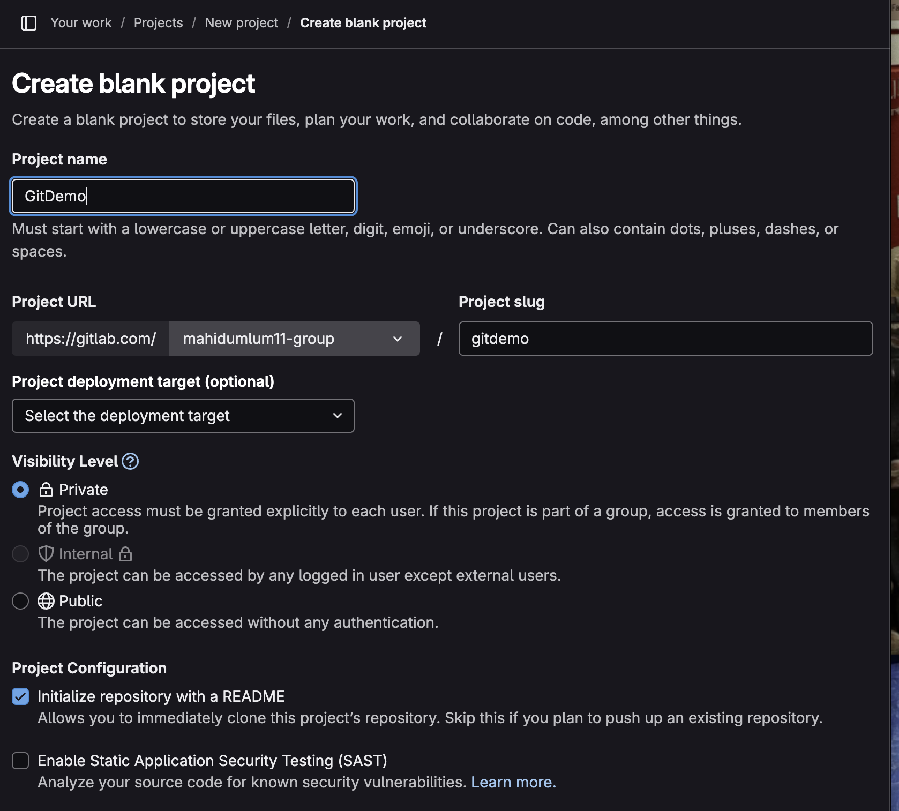**
2. **Installed bbedit which is the closest substitute to notepad++ on MacOs and made it the default editor:**

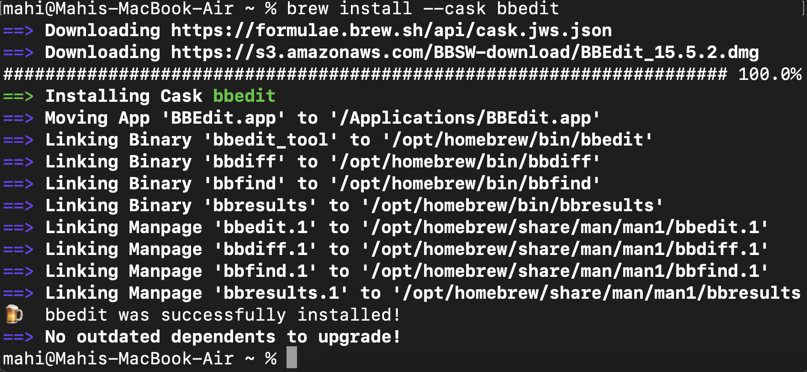

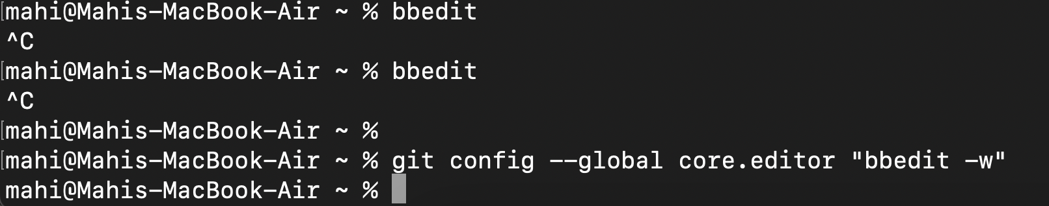

1. **Created GitDemo folder and added “welcome.txt” within it :   
     
     
   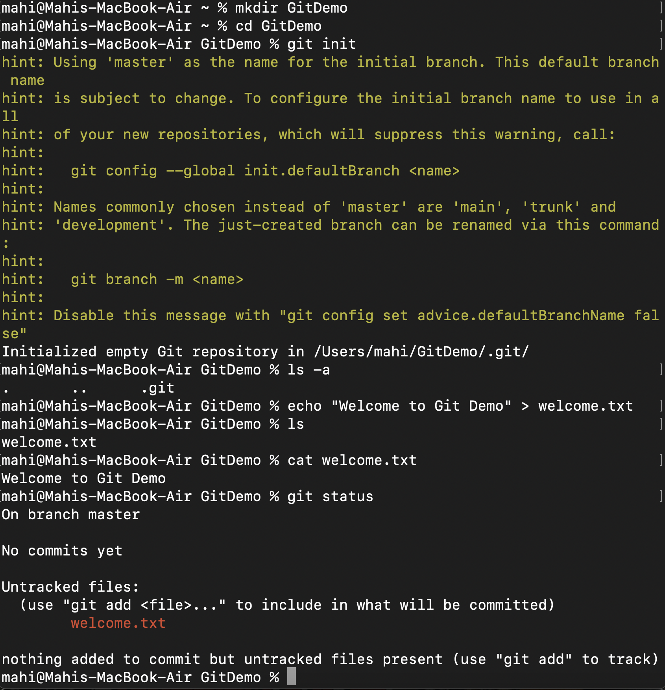**
2. **Committed with bbedit :   
     
   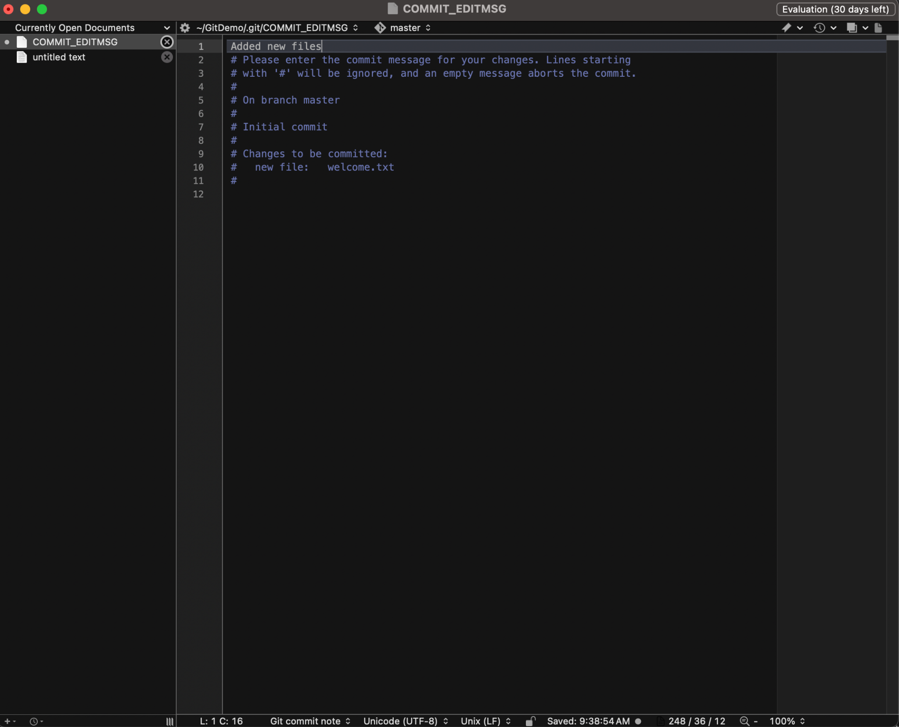**
3. **Made sure it was properly committed :   
     
   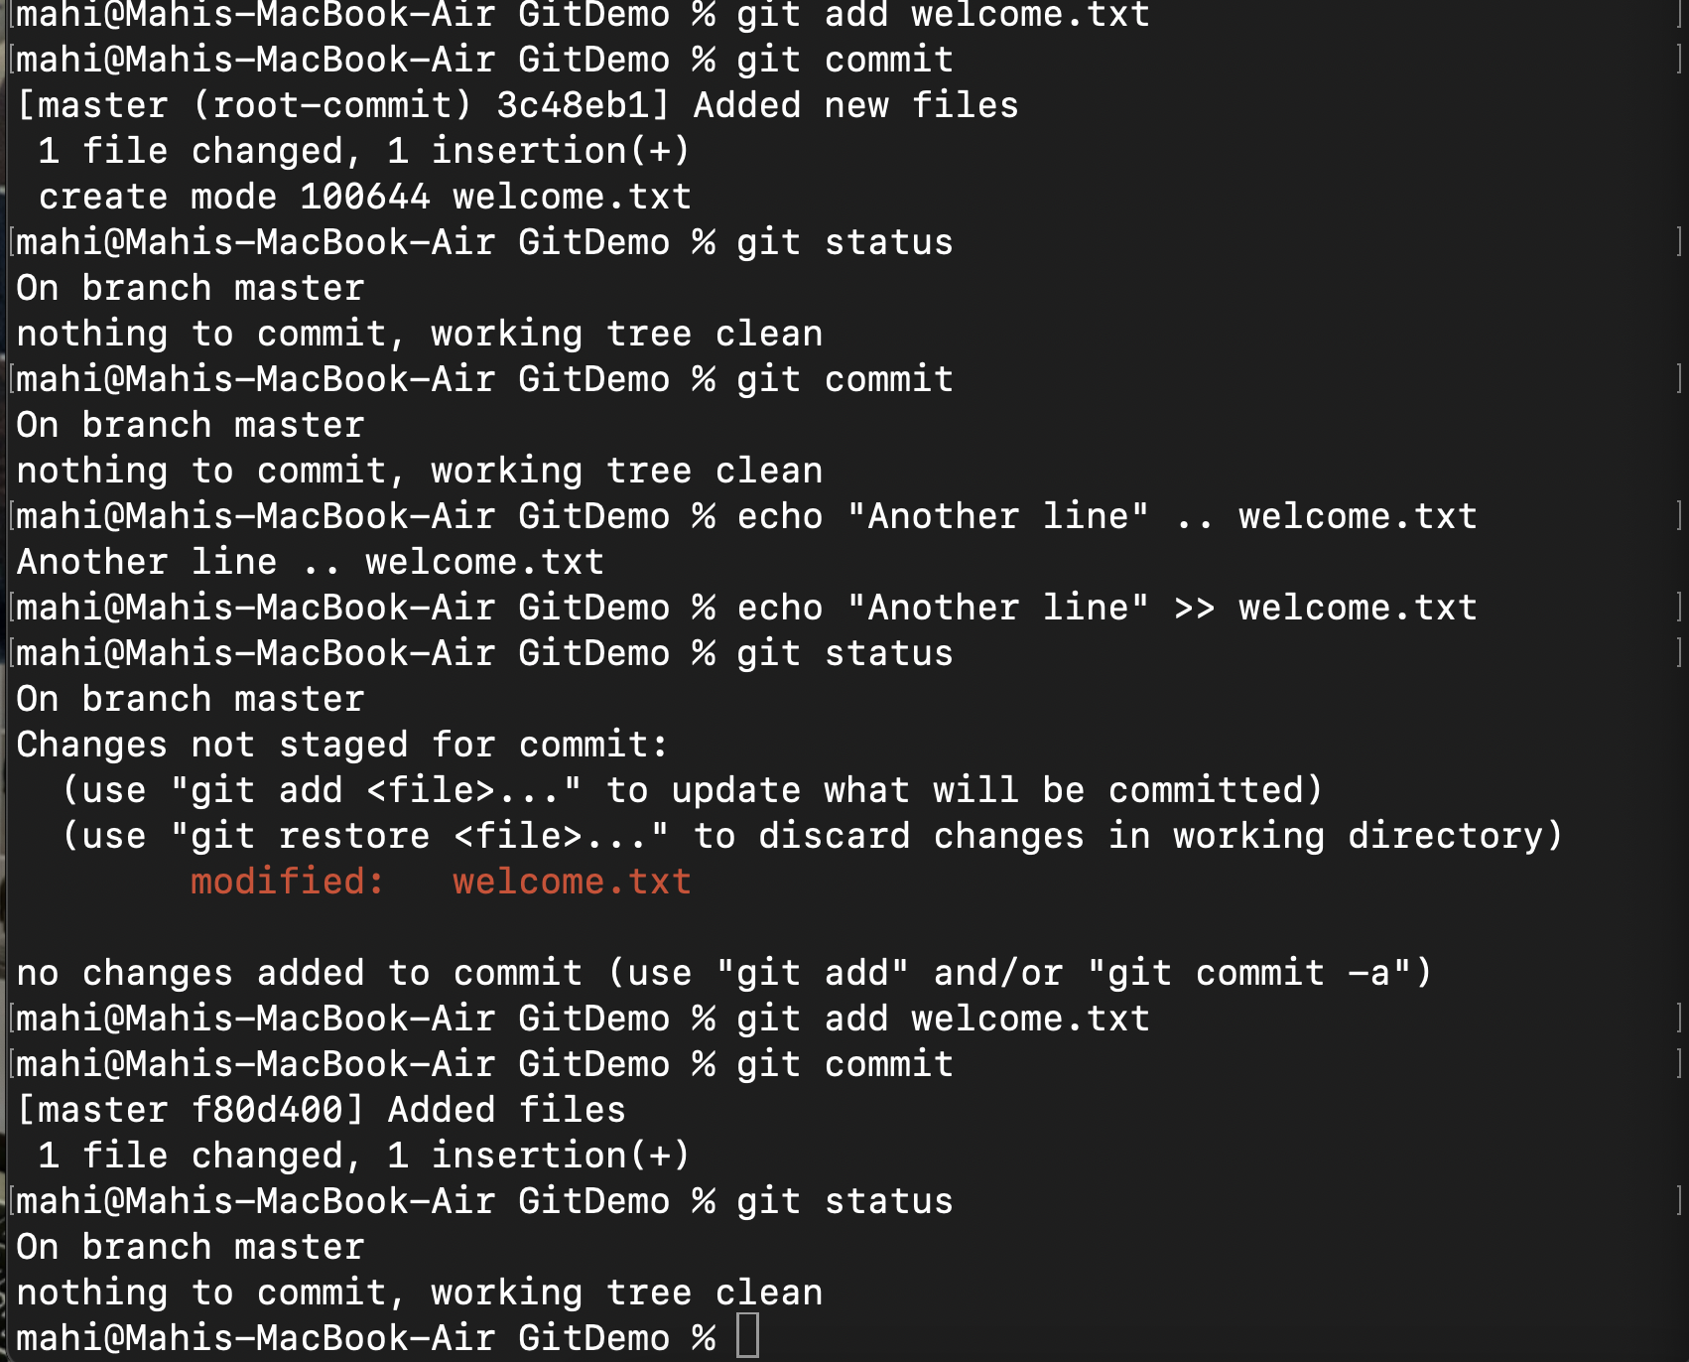**
4. **Verified commit on GitLab :   
     
   